**Four Keys to Fun**

According to Nichole Lazzaro there are four keys to fun, these keys help us when it comes to designing our game since we can decide what type of fun we want and see what features we can put into our game to get the desired response. For example, in our game *Window Bangers* we decided that we were going to put **Social Fun** into our game, so in order to get this type of fun we were going to need to have features that allowed the two players to compare their score in order to see who was doing better and also to communicate with each other in ways such as gloating to get some friendly competition going. We did this by having the score indication at the top of the screen for both players to see while they were taking their turns. Because of this addition the players can joke about the other players score or feel the need to catch up adding pressure to the game.

We also decided to add some hard fun into game by having a feeling of accomplishment when you’ve managed to smash all the windows and got the highest score allowing the player to show who the winner was and that they managed to hit that final window. 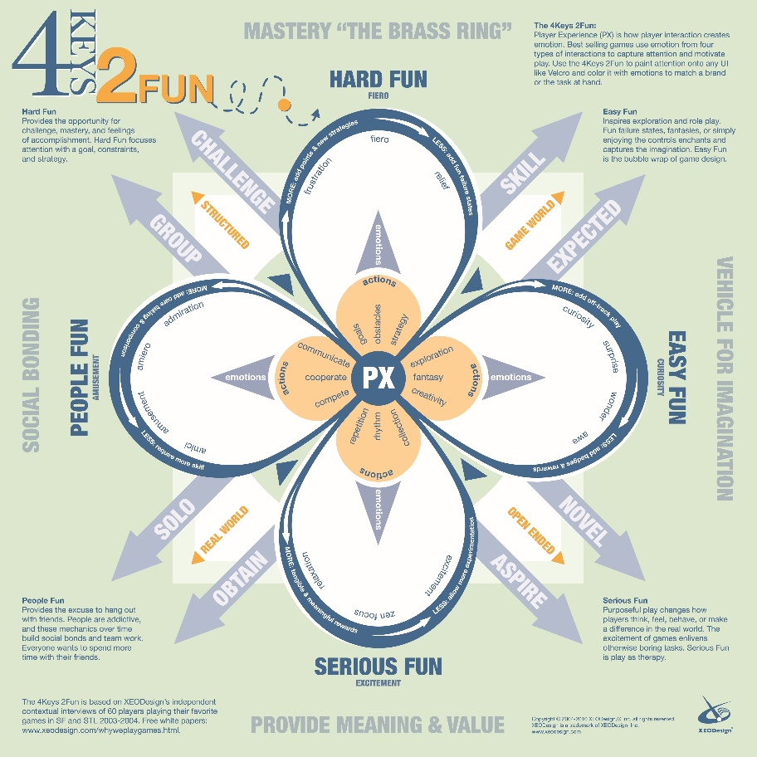

(See Nicole Lazzaro’s 4 keys to fun: <http://www.nicolelazzaro.com/the4-keys-to-fun/>)

**Fiero:**

Fiero is the feeling of overcoming a difficult challenge, this feeling can often be shown by the typical fist going into the air and a “YES!” being shouted. I believe that our game will get players feeling Fiero since as the game progresses the difficulty will go up since there are less and less targets to hit with more space around them to miss. This would start to get frustrating for the player until they hit that final window and feel the rush of breaking that final target. The only problem with this would be that if the player takes too long to break the window then they could get bored of the frustration and stop playing.

**Intrinsic Motivation:**

Our game should give the players an intrinsic motivation by getting them to try and beat the other player, this other player is most likely a friend and so the feeling of competition should cause both players to **want** to win meaning that their motivation is a positive intrinsic motivation. This should cause the players to want to play more since we’re not trying to bribe our players with a reward they should develop this intrinsic motivation for themselves.

(See *Why ‘Motivation By Pizza’ Doesn’t Work* by Alexander Kjerulf:<https://positivesharing.com/2006/12/why-motivation-by-pizza-doesnt-work/>)

**Schadenfreude:**

Schadenfreude is the pleasure that is derived from the misfortunes of others. This can be seen in competitive games like ours when your opponent misses a shot at their intended target or is a couple of points behind you only for you to get a significant increase in score due to a power-up leading to you winning the game. This can be seen in our game with the examples above; player one (P1) might be on 98 points and player two (P2) might be on 95, this is making P2 feel confident and so they take what the think is an easy shot only to miss and not score any points leading P1 to feel Schadenfreude since P2 was misfortunate and is now about to lose the game.

(see *Feeling Good When Others Suffer* by Brian Martin: <http://comments.bmartin.cc/2014/11/12/feeling-good-when-others-suffer/>)